What is AI？
http://lazyfoo.net/articles/article08/index.php

Artificial Intelligence is a complex subject. There are volumes upon volumes written the subject and they can't all be covered in a single article. What this article is here to do is give you a starting point and give you some basics so you can implement some AI in your game.

人工智能是一个很复杂的话题，有很多的书籍对此有讨论，因此不可能简单的涵盖在一篇文章里。这篇文章主要给你一些认识，能让你在你的游戏中实现一些AI。

Artificial Intelligence is about modeling a problem in such a way that a computer can complete a task.

What does that mean? Let's jump right in with an example.

人工智能是通过对问题的建模来让计算机完成任务。这是什么意思呢，我们可以看一下例子。

Tic Tac Toe is a common beginner game to make. Most people who make tic tac toe have little problem making the grid show, handling user input, and checking for wins. A lot of the time though, they'll have trouble making the AI for the game.

井字游戏是一种初级游戏。大多数人制作的游戏对网格的显示，处理用户输入，判断输赢都存在问题。大多数的情况下，他们对游戏的AI制作存在困难。

What you could do is give the computer opponent some sort of pattern to follow.

你可以做的是给电脑对手一些可以遵循的模式。

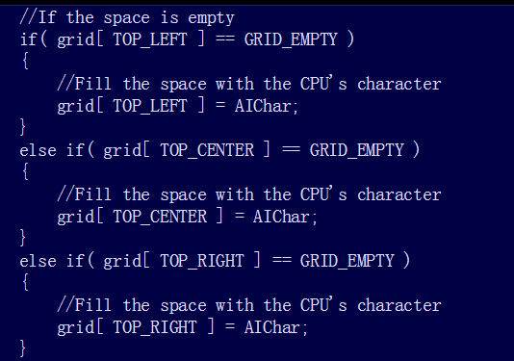
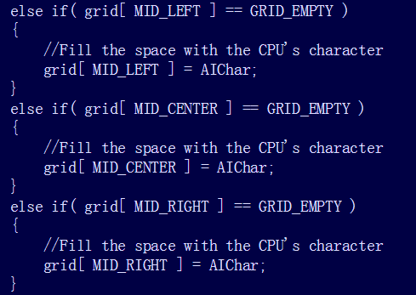
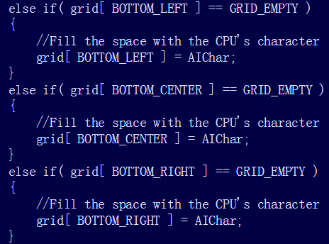

Here the computer just makes a (pretty dumb) set sequence of moves. The problem with this is that the player will quickly pick up on this pattern and easily defeat the computer. Well how do we give the computer some Artificial Intelligence to make it somewhat smart?

这里电脑执行一系列（看起来很笨）的动作序列。问题是游戏选手可以很快的针对这种模式从而击败电脑。因此我们要怎样实现人工智能从而让电脑更聪明一些。

Artificial Intelligence in the most basic sense is a set of instructions the computer has to handle a situation. In this case, the computer has to win a game of tic tac toe against a human player. Now the question is how do you make computer make the move?

人工智能在最基本的情况下是一种处理问题的电脑指令。在这种情况下，电脑需要在井字游戏中赢得人类选手。现在的问题是如何确定电脑的下一步动作。

Well the most basic type of AI you can make for tic tac toe is an opponent that makes moves at random. Let's take a look of what the AI of an opponent that makes moves at random would look like.

井字游戏的最基本AI类型就是随机移动。让我们看看随机移动的AI算法是怎样的。
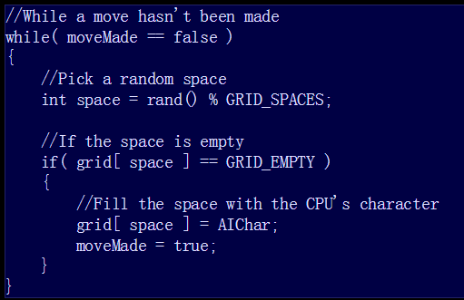

First, this chunk of code selects a space at random. Then we have to check if it's a empty space. If the move is a valid one, we fill the space with the computer's character (X or O). If the move is invalid, we keep picking a new space until we find an empty one.

首先，这块代码随机选择一个空格，然后看是否是空的，如果是空，移动是有效的，我们可以让电脑填入字符。如果移动时无效的，继续选择一个空格直到找到一个空的。

However, for artificial intelligence, this isn't all that intelligent. Real AI has some sort of logic that understands the situation it has deal with. Since the goal of the game is to get 3 in a row, we need to give the computer the ability to complete rows.

当然，对于人工智能，这个不算智能。真正的人工智能具有某种逻辑来理解处理它所面对的情况。因为游戏的目标是连成3行（3列，或斜着），我们需要给予计算机这种能力来完成这个游戏。

井字游戏你可以有8种方式来获胜：
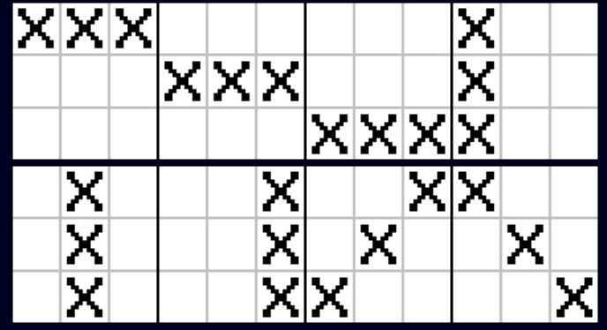

对于每一行，你可以有3种方式来完成：
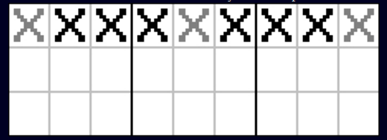

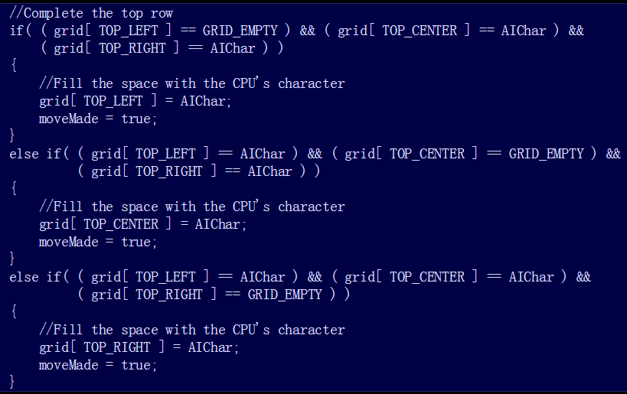

The code to complete the top row would look something like this. The computer now knows how to complete the top row to win. Then you would do the same for the other 7 rows. If you can do the code for one row, you can do it for any of them.

完成第一行的代码如上所示。现在电脑知道怎样完成第一行从而获胜了。接着你需要完成剩下的7种方式。如果你能写出第一行的代码，剩下的基本一样。

Now that the computer has some basic offense, we should give it some defensive strategy. We'll do this by giving it the ability to block the user's rows.

现在，电脑有一点基本的进攻了，我们仍需要给他一些防御的策略。我们会给它去阻止对手完成一行的能力。

就像完成一行类似，阻止一行的完成也有3种方式：
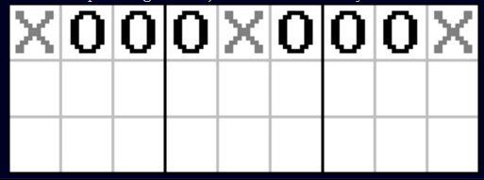
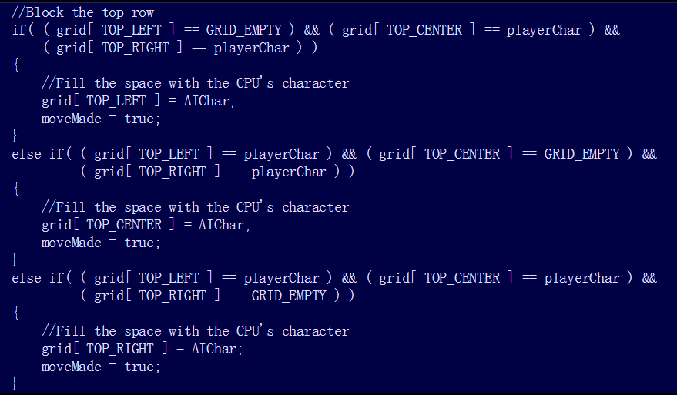

So it only makes sense that the code to block a row looks almost exactly the same as the code to complete a row. In fact you could with the proper tweaks make a function that both completes and blocks row depending on the arguments.

看起来阻止对手的代码和完成一行的代码基本相似。实际上，你可以做适当的调整，让程序根据对手的输入来确定是完成一行还是阻止对手。

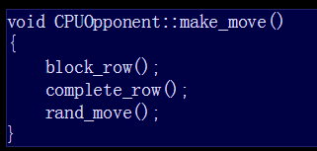

Here's what an AI function for a tic tac toe game might look like. It's simple AI that first tries to block a user victory, then tries complete any rows. If there's nothing to complete or block, it just makes a random move.

这基本就是井字游戏的AI函数了。简单的人工智能首先阻止对手取得胜利，然后尝试完成一行。如果没有什么可以阻止或完成的，就随机移动一步。

However, there is something seriously wrong with how this works. You don't see it? Well let's see how it would run.

但是，这里面的工作有一个很严重的错误，你看到了吗？让我们看看它是怎样运行的。

O是用户，X是计算机（计算机先走）
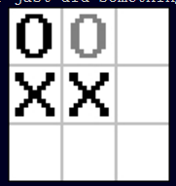

This is a sure victory for the computer right?
这种情况下肯定是计算机赢，不是吗？

但计算机的AI算法会这样走：
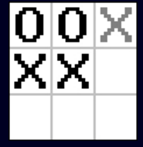

Like with game loops, the AI has to do things in the right order to work properly. Blocking has higher priority, so even if the computer can win in this move, it's going to try to block the user first. This means the complete_row() function should go before the block_row() function. It doesn't matter how nice your AI algorthims look, if they don't happen in the right order they aren't going to work. So be careful how you prioritize your AI actions.

就像游戏循环，AI以正确的顺序来完成任务。阻止对手拥有更高的优先权，即时是计算机完成一行就能取得胜利，也会有限去阻止对手。这就说明了 complete_row()函数应该在block_row()函数调用之前。不管你的AI算法看起来多么不错，如果它们没有按照正确的顺序来排列，依然会执行不正确。因此你要谨慎的优化你的AI算法。

Now that your AI has basic offensive and defensive abilities, you probably want to put some higher level strategy. We'll do this by adding in some traps. The best way to explain a trap is by example.

现在你的AI有了基本的进攻和防御能力了，你可能会想加入一些更高级的策略。我们会加入一下圈套（陷阱），让我们来看看。

对手走了这一步，
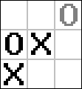

如果计算机能走这一步：
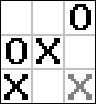

那么不管对手走哪一步，计算机都会赢：
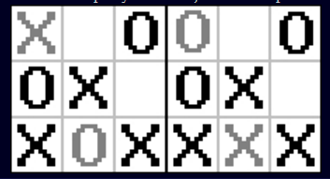

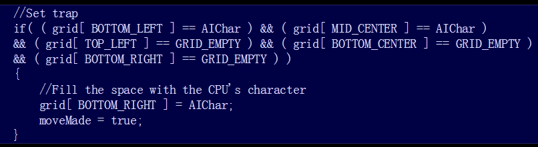

Here's what the code of this trap would look like. The AI checks that the right spaces are empty and that the right spaces have the AI's character and then it sets the trap.

How many traps are there? Each trap requires two rows that share a space.

这就是设置圈套的代码了。AI检查特定的空格是否是空的，特定的空格是否是AI自己的字符，然后设置圈套。

总共有多少个圈套？每个圈套需要共享同一个空格的2行。

在这个例子里，是这两行：
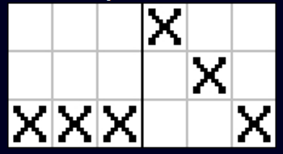

This means there are is a set of traps for each unique pair of rows. For each of those pairs, there must be 3 spaces with the AI's character, one being the space they share.

这就意味着每一对独立的行都有一个圈套。对于每一对，都必须有3个空格填有AI的字符，其中一个是这两行共享的。

这是这一对的所有圈套：
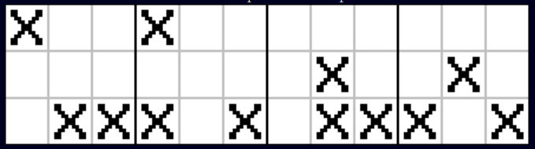

对于每一个圈套，有3种方式来实现
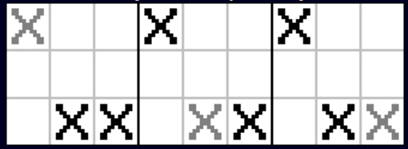

So now you know how to make every single possible trap. Blocking a trap is almost exactly like completing a trap. As with blocking rows you simply detect a possible trap by the player, then you put the AI's character in the place that would complete the player's trap.

现在你知道怎样做每一个可能的圈套了。阻止一个圈套和完成一个圈套基本类似。正如阻止一行的完成，你只要检测对手可能的圈套，然后用AI算法来阻止对手完成圈套。

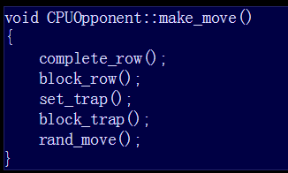

This is what an AI function with all the actions we talked about would look like. Again notice how the actions are prioritized. We have the move fundamental actions of completing and blocking rows go first. Then we have higher level strategies of setting and blocking traps. Lastly, we have a function to make a move at random so if there isn't any important actions to do, the AI will not just sit there and do nothing.

这就是所有我们讨论的AI函数操作了。再一次提醒操作的优先权。我们的基本行动是先完成一行，再接着是阻止一行。接着我们设置和阻止圈套，最后是随机移动，这样我们的AI就不会没事干。

This may seem boring, but all these fundamental AI concepts apply to many different types of games. First we talked about giving the computer some patterns to follow. This can work in situations where AI isn't important like shoot 'em ups or generic enemies in a platformer.

这个看起来有点无聊，但是这些基本的AI概念运用在不同种类的游戏上。首先我们谈论了给计算机一些遵循的模式。这种模式能运用在不重要的AI算法上，比如射击或游戏平台的通用敌人。

Then we covered making sure that the AI makes a valid move. In an RPG for example, you can have an enemy cast a magic spell against the player, but you have to design the AI so it can't use the spell if it doesn't have enough magic points or if it isn't at a high enough level to use it.

然后我们介绍了如何确保AI进行一个有效的移动。举个例子，在RPG游戏中，你可以有一个敌人，用魔法法术来攻击玩家，但是你必须设计一个AI算法来确保在魔法点数不够或等级不高的时候不能使用法术。

After that, we talked about giving the AI the basic action it needs to win and defend itself against the player. In a shooter, you should have the AI shoot at an enemy when they see one and pick up a nearby health pack when they're low on health. You should also have the AI properly prioritize these actions. If there's a health pack nearby and the AI encountered an enemy, it should be able to judge whether its primary concern is going for the health or finishing the enemy.

之后，我们讨论了如何让AI具有基本的行动来获取胜利或者保护自己。在射击游戏里，当AI看到敌人时，你应该让它射击敌人，当hp值较低时，应当捡起附近的养伤药。你应该要AI适当优先考虑这些行动。如果附近有养伤药和一个敌人，它应该能判断它所关心的是健康还是射击敌人。

Then there's higher level strategy like in a war simulation. You can make the fighters have different formations to maximize the damage they can do as a team. When you have different levels of strategy you have to properly layer them. Let's say you have a set of fighters trying to surround an enemy, but some of those fighters are being attacked by other enemies. Those units should know to try to stay alive because they're no good in surrounding an enemy if they're dead.

还有更高层次的战略，就像模拟一场战争一样。你可以让一个团队里的战士有不同的形态来最大化的给敌人造成伤害。当你有了不同的策略时，你应该要适当的分配好。假如有一组战士尝试包围敌人，但其中一些战士受到了敌人的攻击。这些战士应该尽量去活着，如果他们死了，那么就不能包围敌人。

When we covered making the AI for all this, we had to think about what were the possible situations the AI could run into. So when you make your AI, you have to think "what moves can be used by the player", "what obstacles could I run into?", "what weapons can I use?", etc, etc.

当我们让这些AI覆盖所有行为时，我们不得不思考AI会遇到的所有可能的情况。因此当你创建AI时，你必须考虑，“如果我是用户，下一步我应该怎么走”，“我会遇到什么障碍”，“我可以使用什么武器”等等。

Lastly we talked about implementing some sort of idle fail safe. In the tic tac toe game, if there's nothing to set up or block, we have it pick a move at random. This sort of concept applies to other games, too. At the start of a round in a game, since there's nothing to shoot at, no items to pick up, or no enemies to surround, the computer is just going to stand there.

最后我们讨论了某种空闲的不安全状态。在井字游戏里，如果没什么可选的或阻止的，我们就随机的选择一步。这种概念也适用于其它游戏，在第一轮的游戏开始，因为没有什么可以射击，没有什么可以捡起，没有敌人包围，计算机只会站在那里。

When coming up with AI, it's a waste of time coming up with an action for every single possible specific situation. So if the AI has nothing to do, you can have it pick an action or strategy at random and have it follow through with that. You can have it take the high way, the low way, the side way, or you can have it pick a location and camp it. It's much better than having it do nothing.

当提出人工智能时，对于每一种特定的情况想出一个动作是很费时间的。如果AI无事可做，你可以让它随机选择一个行动或策略，然后遵循下去。或者让它选择一个高位，一个低位，一个边位，或者让它选择一个位置或营地。这样总比什么都不做好。

Obviously most video games are more complicated than tic tac toe. The only moves a player can make is putting a character in an empty space. What about all the other games that have objects moving all over the place and doing all their various actions? Let's jump right into an example with Street Fighter 3: 3rd Strike.

显然大多数的视频游戏比井字游戏复杂多了，一个玩家所能移动的动作只是把一个字符填入空格。对于其它拥有对象，能移动到各个地方和做出各种动作的游戏，它们是怎样的呢？让我们进入到街头霸王的例子中吧。

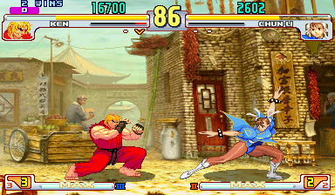
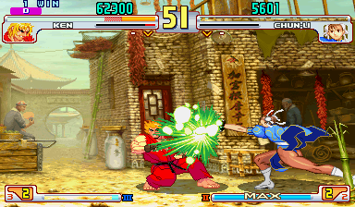

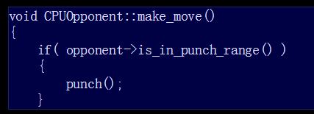
Here's some over simplified psuedo AI code that hits the opponent if they're nearby. Any of you that played the game know there's a problem with this code.

这里是一些简单的AI伪代码，当接近对手时，就打对手。如果你玩过这款游戏你就知道这些代码是有问题的。

If the AI tries to punch the opponent while they're doing a super, they're going to get hit:
如果当AI准备发大招的时候，同时在尝试打击对手，那么他们就会被攻击：
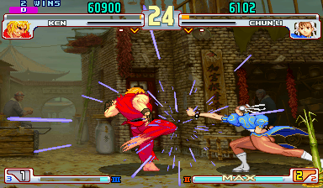
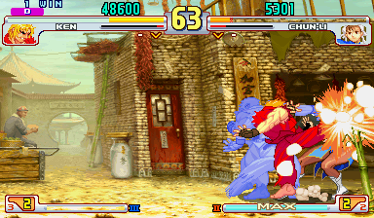

How do we take into account all the actions the opponent can do? We can do it with a state machine.

我们如何考虑对手的所有动作？我们可以通过状态机达到目标。

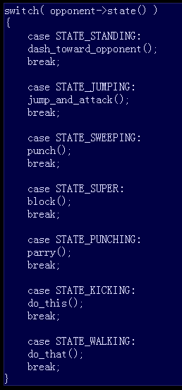

Here's some more over simplified psuedo AI code, but this time it uses a state machine. Now the AI will know to block when the opponent is doing a super even if they're within punch range.

这里是更多的简单AI伪代码，但这次使用了状态机。现在，AI会阻止准备发大招的对手，即时是AI正在对手的打击范围内。

State based AI has the computer take action depending what the opponent is doing, so it can take a counter measure. State based AI applies to just about any game:

基于状态的AI可以根据对手的状态来决定自己的下一步动作，因此它可以采取对应的措施。基于状态的AI也适用于其它游戏：

- If the player is shooting at the AI player, head towards cover.
- If the player threw a fire ball, try to dodge it.
- If the player has poisoned the AI player, cast a healing spell.
- If the player is about to catch the ball, try to intercept it.
- If the player is attacking the base, go and defend it.

- 如果玩家正在射击AI，AI会躲避（把头朝向盾牌）
- 如果玩家扔火球，AI会试图躲避
- 如果玩家使AI中毒了，AI会尝试治疗
- 如果玩家即将捉到球，AI试图阻止他
- 如果玩家正在攻击基地，AI会去保护基地

So when you design you AI, think about the various actions the player can take and have a set of actions for each of those situations.

因此，当你设计AI时，你需要考虑玩家的各种情况从而制定出对应的处理方式。

Another thing to watch out for when designing AI is making the AI "too smart". Computers can make thousand upon thousands of calculations per second. They can in an instant calculate the precise angle to aim at the player to kill them instantly with a head shot. The reaction time of a computer is a tiny fraction of a second so it will notice you doing a move before your action is rendered to the screen. It can calculate the range of a collision box down to a pixel. It can also instantly find out the location of anything in the game. If you make your AI too hard, people won't want to play your game.

Let's do some pong AI for example.

另一件要注意的事就是当你设计AI，想让它变得更聪明的时候。因为计算机每秒能进行成千上万次的计算，它们能在瞬间计算出精确的角度来针对玩家进行爆头杀死他们。还有计算机的反应时间只需要一秒钟的一小部分，当你移动的一个小动作还没呈现到屏幕时，计算机就能注意到了。它能计算出盒子碰撞范围的每一个像素，也可以立即找出游戏中的任意一个位置，因此，如果你让你的AI太难了，人们就不会想玩你的游戏。

让我们做些例子：

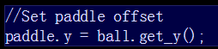

With this code, the paddle will always line up with the ball and it will never miss. This means the AI will never lose.

在这段代码里，桨和球总是排列在一起，因此它们不会分开，这也意味着AI永远不会失去。

In order to give your AI a more human like feel, you have to give it some inaccuracy.
为了能让你的AI更像人类，我们必须给它一些不准确。

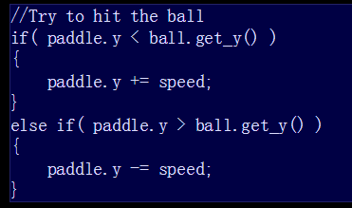

Now this AI is more playable. Instead of always lining up with the ball, it moves toward it at a varying speed. This mean it could not get to the ball on time or it could over shoot the ball. Now a human has a chance of beating AI.

现在AI可玩度更好了。桨和球不会永远并在一起了，桨会朝着球以不同的速度接近，这意味着桨不会准时接到球，或者会用力过度的击球。现在玩家有机会打败AI了。

A human can't instantly react to something, so your AI should wait a reasonable amount of time before reacting. A human can't instantly find out what "player.x" and "player.y" are so the AI should have to look for the opponent. So when you design your AI make sure to ask yourself "Can a human do this?".

人类不能对任何事件作出立即反应，英雌你的AI在反应前也应该等待一段合理的时间。人类不能立即找到 玩家.x 和玩家.y，因此AI也要这样来寻找对手。因此，当你设计AI时，你一定要问自己“人类可以做到这样吗”。

This brings me to my next topic of varying difficulty. It's a common feature for video games to have multiple difficulty settings. This is so people new to the game don't get frustrated because it's too hard and people who already have experience with the game don't get bored because it's become too easy. It's also good game design to have the difficulty of the game to steadily increase as you progress so it doesn't become repetitive.

这带到了我下一个关于各种困难的主题。视频游戏普遍存在的特点就是有很多困难的等级。对于新手来说，因为太难了会使得他们感觉到丧气。对于已经体验过游戏的人来说，他们不会感觉到无聊，因为它变得容易了。因此，好游戏的设计，应该是随着你的进度，游戏难度一层一层的增加，这样就不会变得重复。

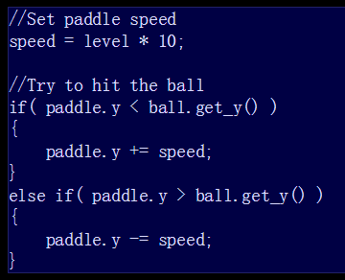

Here's the pong AI once again. Now as the difficulty level increases, the paddle moves faster so it becomes harder to defeat.

这次，随着等级的提高，难度会提高，桨会移动得更快，因此也变得更难击败了。

The key to having variable difficulty is to have different actions depending on the difficulty setting. The harder the difficulty the more aggressive, skilled, and intelligent the AI should be. For the easier difficulties, the AI should just use the most basic actions, and maybe you could lower it's ability to aim or react.

设置不同困难等级的关键是根据不同的困难设置拥有不同的困难动作。困难等级越高，AI就越聪明，越厉害。对于简单等级，AI应该只适用最基本的动作，也许能降低它的能力和反应。

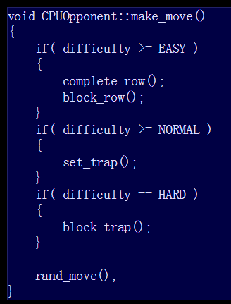

Here's another example of variable AI with tic tac toe.

这是另一个井字游戏的例子。

On the easy difficulty the AI will just do the minimum of completing and blocking rows. On normal it will try to trap you when it can. On hard it will also try to block your traps. So as the difficulty increases, the AI uses better tactics to defeat the player.

简单的等级，AI会最小的完成或阻止一行。普通等级会尝试设置圈套。困难等级会尝试阻止你的圈套。因此，随着难度的增加，AI会使用更好的策略来战胜玩家。

We've only scratched the surface of what AI is. I tried to cover the basic concepts that can be applied to most games. There's so much more that goes into AI like knowledge of geometry, linear algebra, statistics, path finding algorithms, constraint satisfaction problems, and even psychology. Hopefully now you at least have enough to get started.

我们只触及到表面的人工智能是什么，我涵盖的基本概念适用于大多数的游戏，对于人工智能，还有很多知识要学习，比如几何知识，线性代数，数据统计，寻路算法，约束满足问题，甚至是心理学。希望你现在至少有足够的认识去开始学习人工智能。

